Riphah International University

Gulberg greens Campus

Submitted by : Mahnoor Ahmed
Sap id : 80207
Submitted to : Mam Nayab Khalid
Lab # 06

Task 1:
The team has many players but each player can exist without the team (he can join another team.)
• Create a Player class with jerseyNo, and name.
• Create a Team class with a list of Players.
• Deleting the Team must NOT delete the Players.
• In main, create some Players, add them to the Team, and display them.

Program:

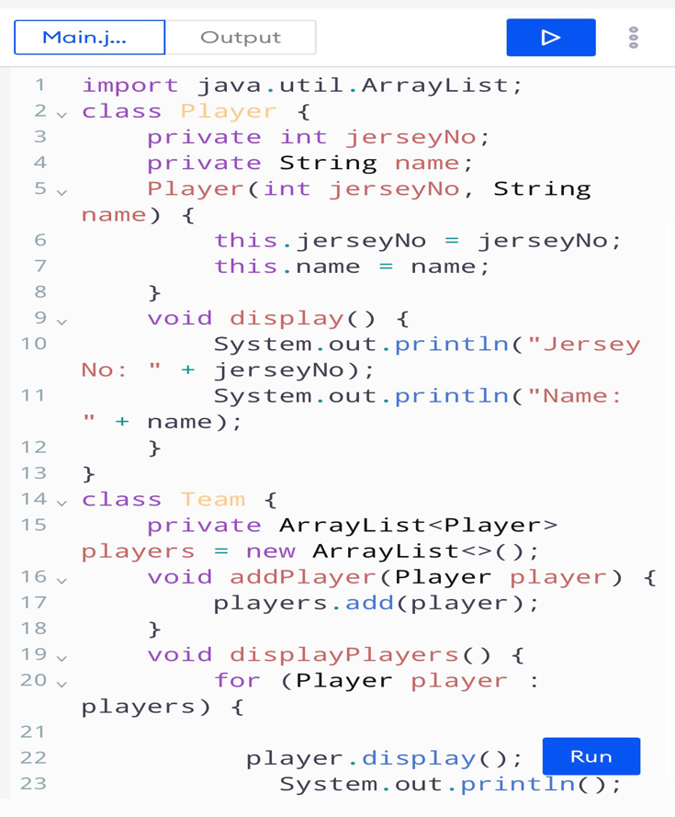

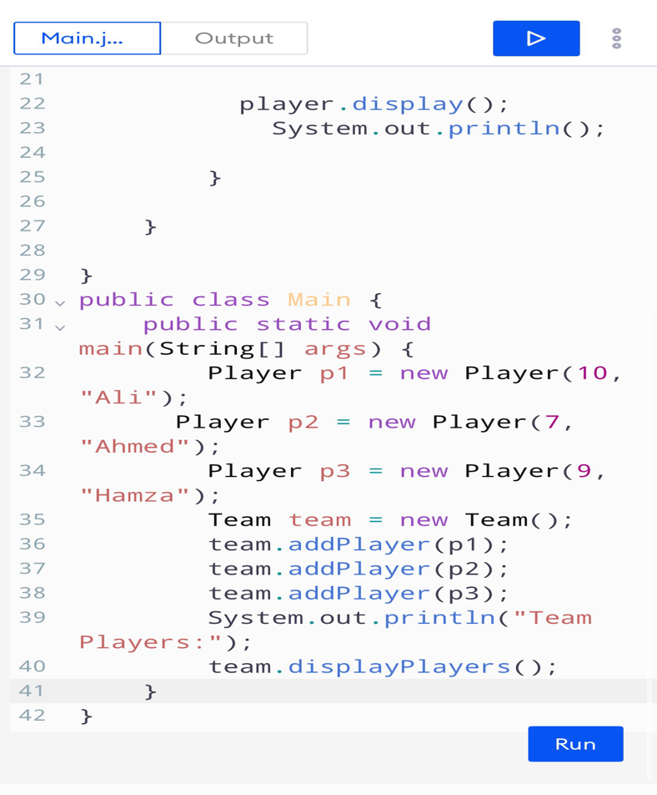

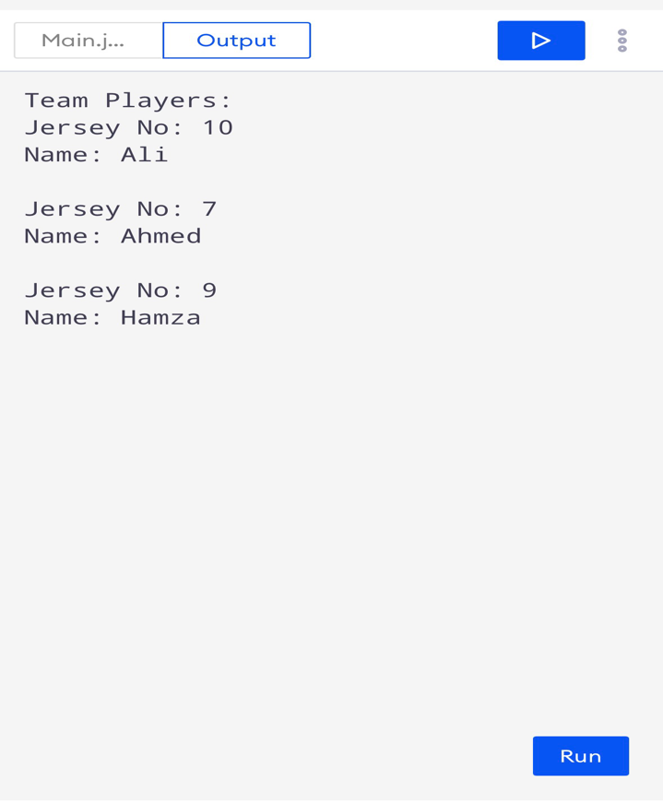
Result
Task no .2
A Car has an Engine. The Engine is built inside the Car and cannot exist without it.
•Create an engine class with a start() method that prints a message.
•Create a car class that makes its own engine inside the constructor
• In main, create a Car and call dri ivef), which starts the Engine.

Program :

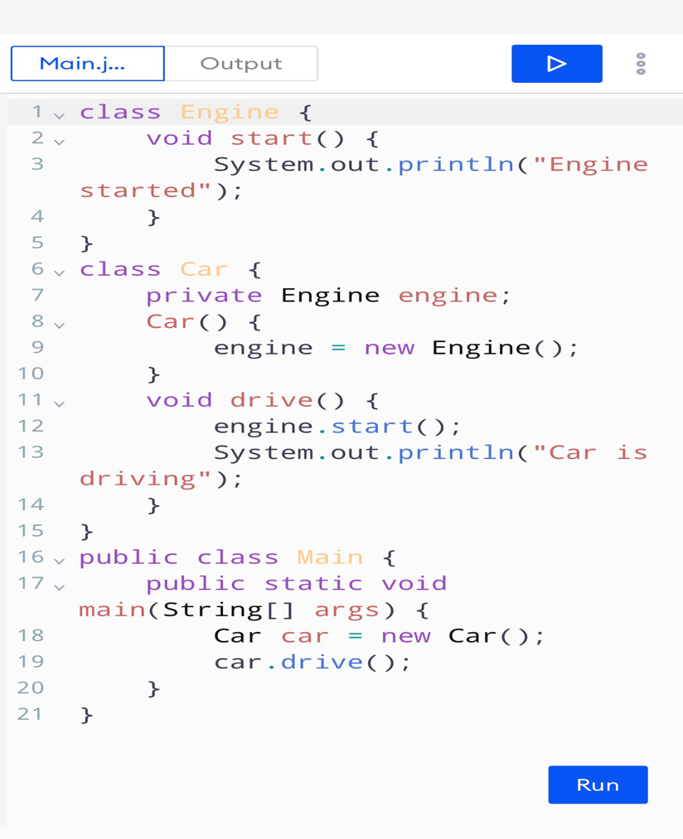
Result :


